Phase 3
Team: Delta4 | Number: 100 | Spring 2026

Ultima Interface
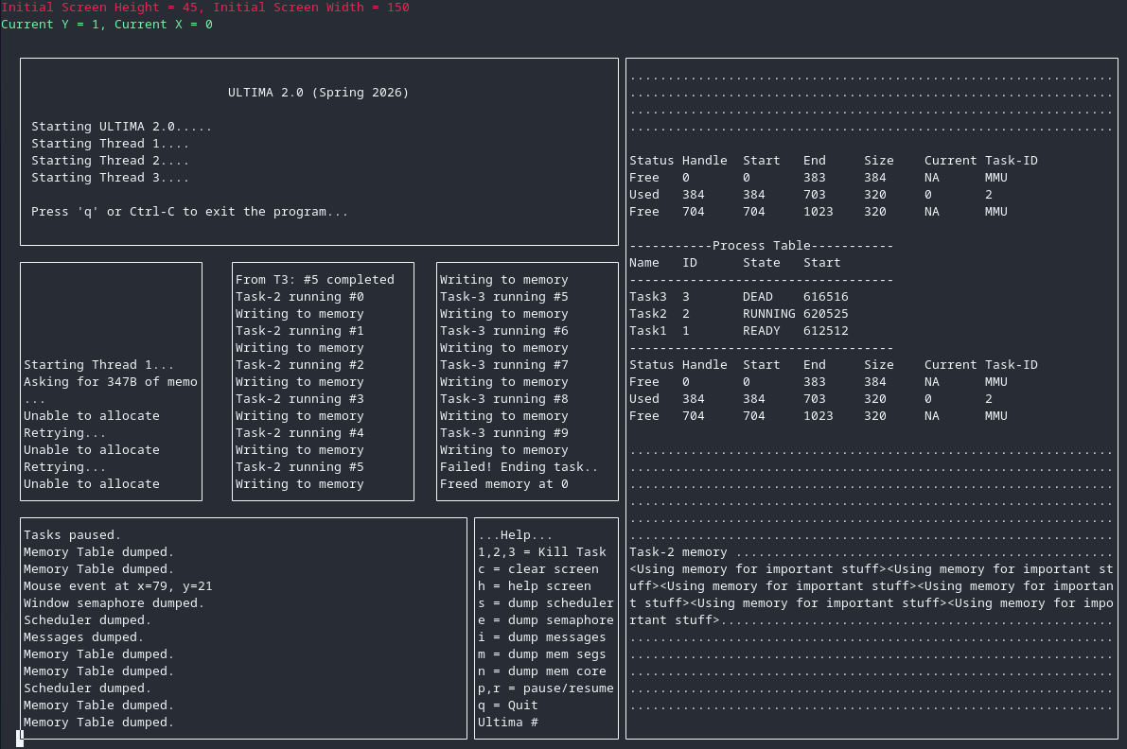
The interface has been updated to incorporate the new memory management system, along side the other systems developed in the last two phases. In the right side of the screenshot, printouts of the scheduler, memory segments and memory core are visible. In this state, task #3 has already executed; having already allocated and freed some memory. Task #2 is running; storing values in memory, and sending IPC messages to another task. Finally, task #1 has not been able to allocate memory, since not enough memory was available (before task #3 finished). Whenever task #1 starts running again, it will pick up the newly freed memory, and start performing its work.

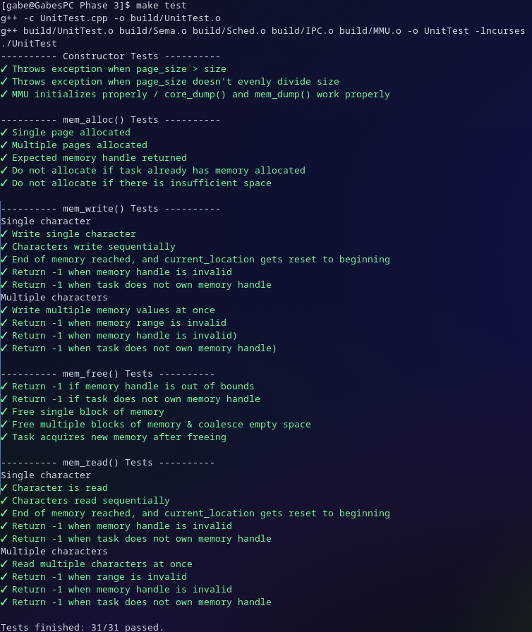
Testing
We took a different approach to testing for this phase. We created the unit tests for the new MMU class BEFORE the class was implemented. That way we could verify the class is working properly as it was being developed, and more evenly divide the workload between the teammates.
This screenshot shows the results of executing the unit test file. A list of test cases was created to cover every functional requirement for each class function.

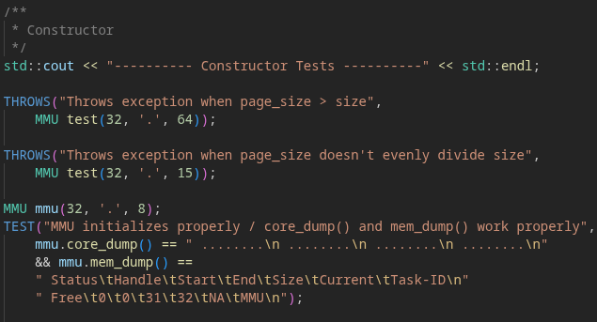
This screenshot shows a portion of the unit testing code. Tests are performed in test blocks through the use of macros. For each test shown in the screenshot above, a TEST block is added and assigned a name, and the test expression is provided. Since the tests were created before the class was implemented, we tested the output of the dump functions against what we expect the dump to be. There are also tests that ensures the provided code snippet throws an exception.

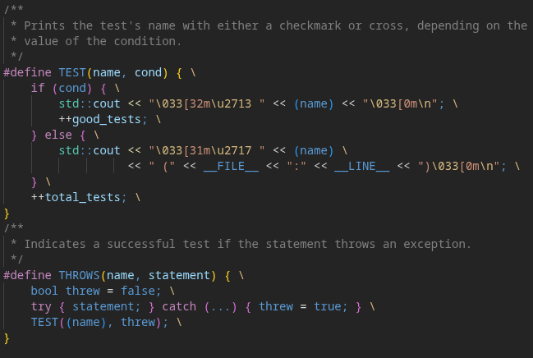
These are the testing macros we used. It will print the test name in green next to a checkmark if the tests passes, and if it fails, it prints red next to an x mark. It also tallies the total number of tests, and how many succeeded.

